Compsci Coursework Project

Req: Submit evidence of the following:
- Stakeholder and target audience summary
- Research into similar games, apps, tools or systems
- Initial feature list, preferably using MSCW
- Evidence of language, IDE or framework upskilling
- A short development preparation log
Contents
Compsci Coursework Project 1
Project Definition 1
Stakeholders and Target Audience 2
Research Similar Products 2
Example 1: Dead Cells by Motion Twin 2
Example 2: Undertale by Toby Fox 2
Some more relevant games I researched (and enjoyed enough to mention): 2
Initial Feature List 2
Must have: 2
Should have: 3
Could have: 4
Won’t have: 5
Development 6
Coursework Weapons and Combat 6
References 7

Analysis

Project Definition
My project will be a 2D Action-Platformer, with Roguelite and Metroidvania elements. It is inspired mostly by the game Dead Cells, so will loosely be based off of that. The art-style will be simplistic and created by me.

Stakeholders and Target Audience
My target audience would be anyone who enjoys playing roguelite/metroidvania genre games, most likely ages 12+ as the game will feature some combat elements that may be unsuitable for younger players. I am choosing this category of target audience as many of my friends (and myself) fall into it, so I have many people I could interview regarding the game’s development and features. They may play similar genre games such as Hollow Knight or Dead Cells, or be completely new to the genre. I aim to make the game with a low skill floor so anyone can enjoy it, but feature a very high skill-ceiling so it also appeals to more experienced players, and allows for vast improvement in strategy and gameplay.

Research Similar Products

Example 1: Dead Cells by Motion Twin

General Overview
This game reflects a lot of features that I would like to include in my own. Primarily, the genre is a Roguelite Platformer with combat elements and Metroidvania aspects to the level design. Every run, you try to reach a door to the next level (or biome) and can optionally fight enemies to collect “cells”, the game’s form of upgrade currency. Between levels, you can spend these on permanent upgrades that help you progress through the game. Moreover, there are some sporadic boss fights in certain biomes that let you receive “runes”, which essentially give Dead Cells the Metroidvania aspect, as they give extra abilities (often movement based, or environment utility). There are in total 24 standard biomes, where the layout is randomly generated each run, and 12 boss biomes where the design stays consistent.
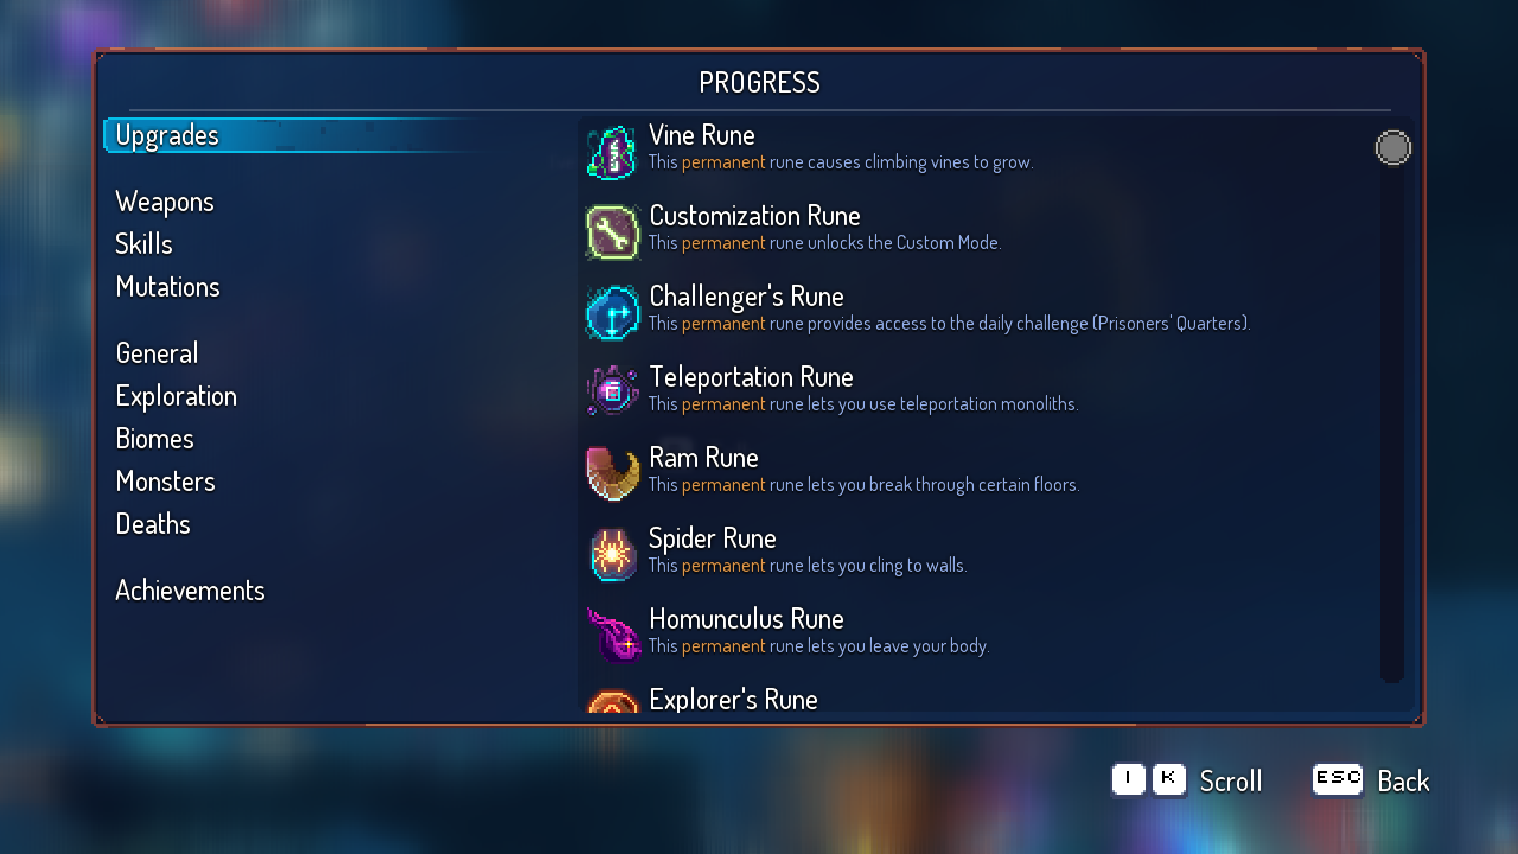
^There are many runes available to collect – these are mostly collected linearly and open the map up more, in the standard metroidvania style.
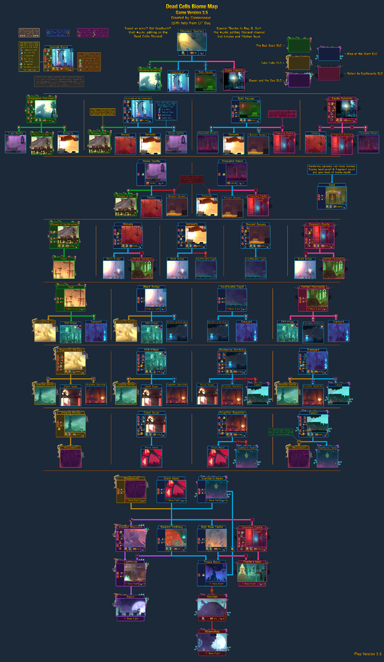(reminder to reference)
^ There are a huge number of biomes in the game, all with unique design, enemies and other gimmicks. Progression is monodirectional however there are usually multiple paths to each biome.
Some specific elements I enjoyed were the all-or-nothing aspect to upgrades – when you play a level, you collect cells, but you can only keep them for upgrades if you make it to the end, otherwise if you die mid-run, you lose them all. I like this approach to roguelite upgrades as it makes the game have more risk, and a pressure on survivability as well as combat, and setting the different maps/levels as checkpoints gives consistency and modularity.
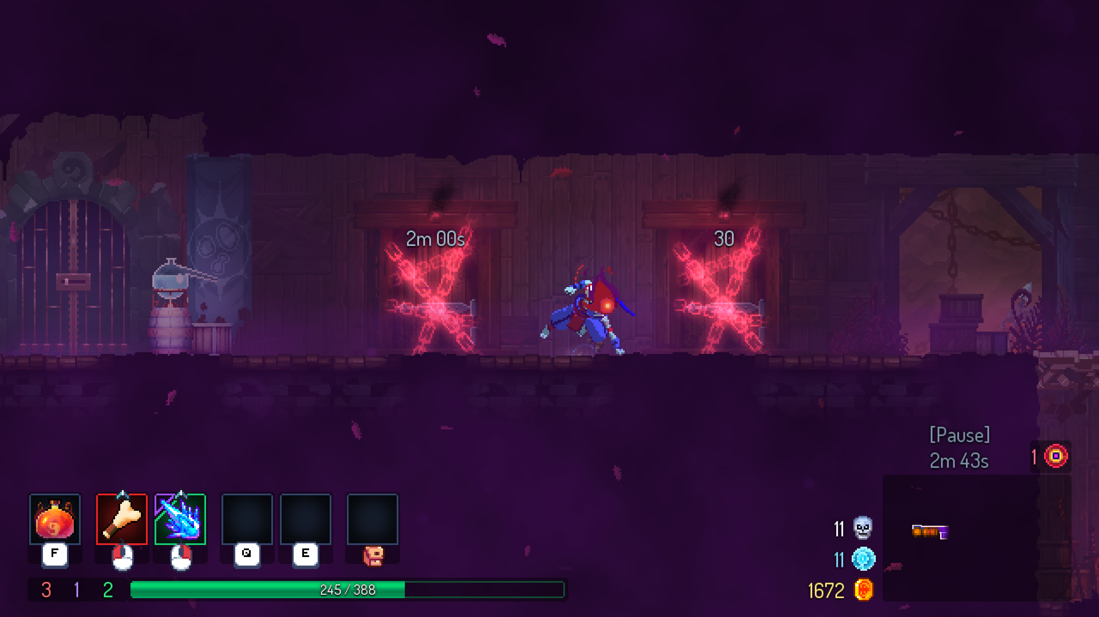
^ If you complete a biome within a certain time or with a certain hitless killstreak, you can gain extra gold and cells.
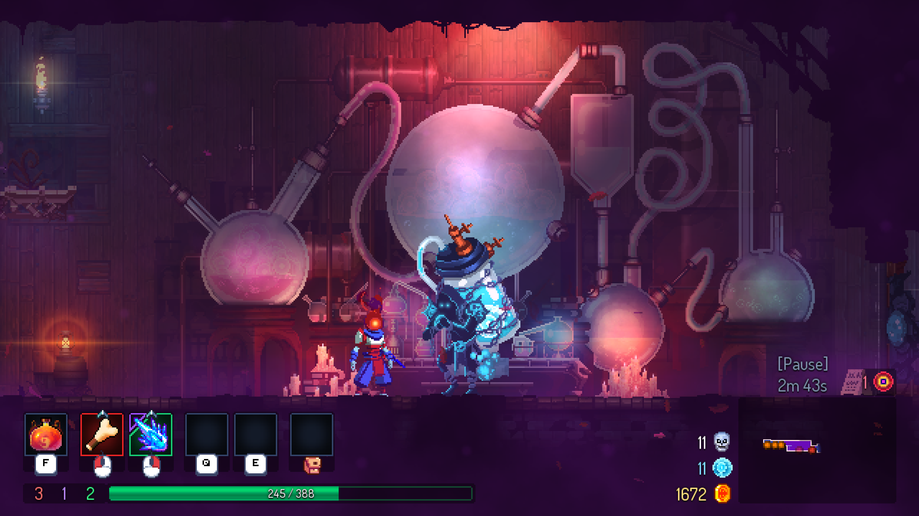
^ After every biome you can spend the cells you collected towards permanent upgrades, these include weapon unlocks, mutations, or general quality of run upgrades such as more health potion uses before refill.

I also enjoyed the replayability of the game, as aside from its many expansions and biomes you unlock through progression, to officially “beat” Dead Cells you essentially have to complete the game 6 times. Each time you defeat the final boss, you get a “Boss Cell”, which drastically increases difficulty in exchange for better items and the ability to progress again. While this may be difficult to effectively implement in my own game, it did make me enjoy playing Dead Cells a lot more
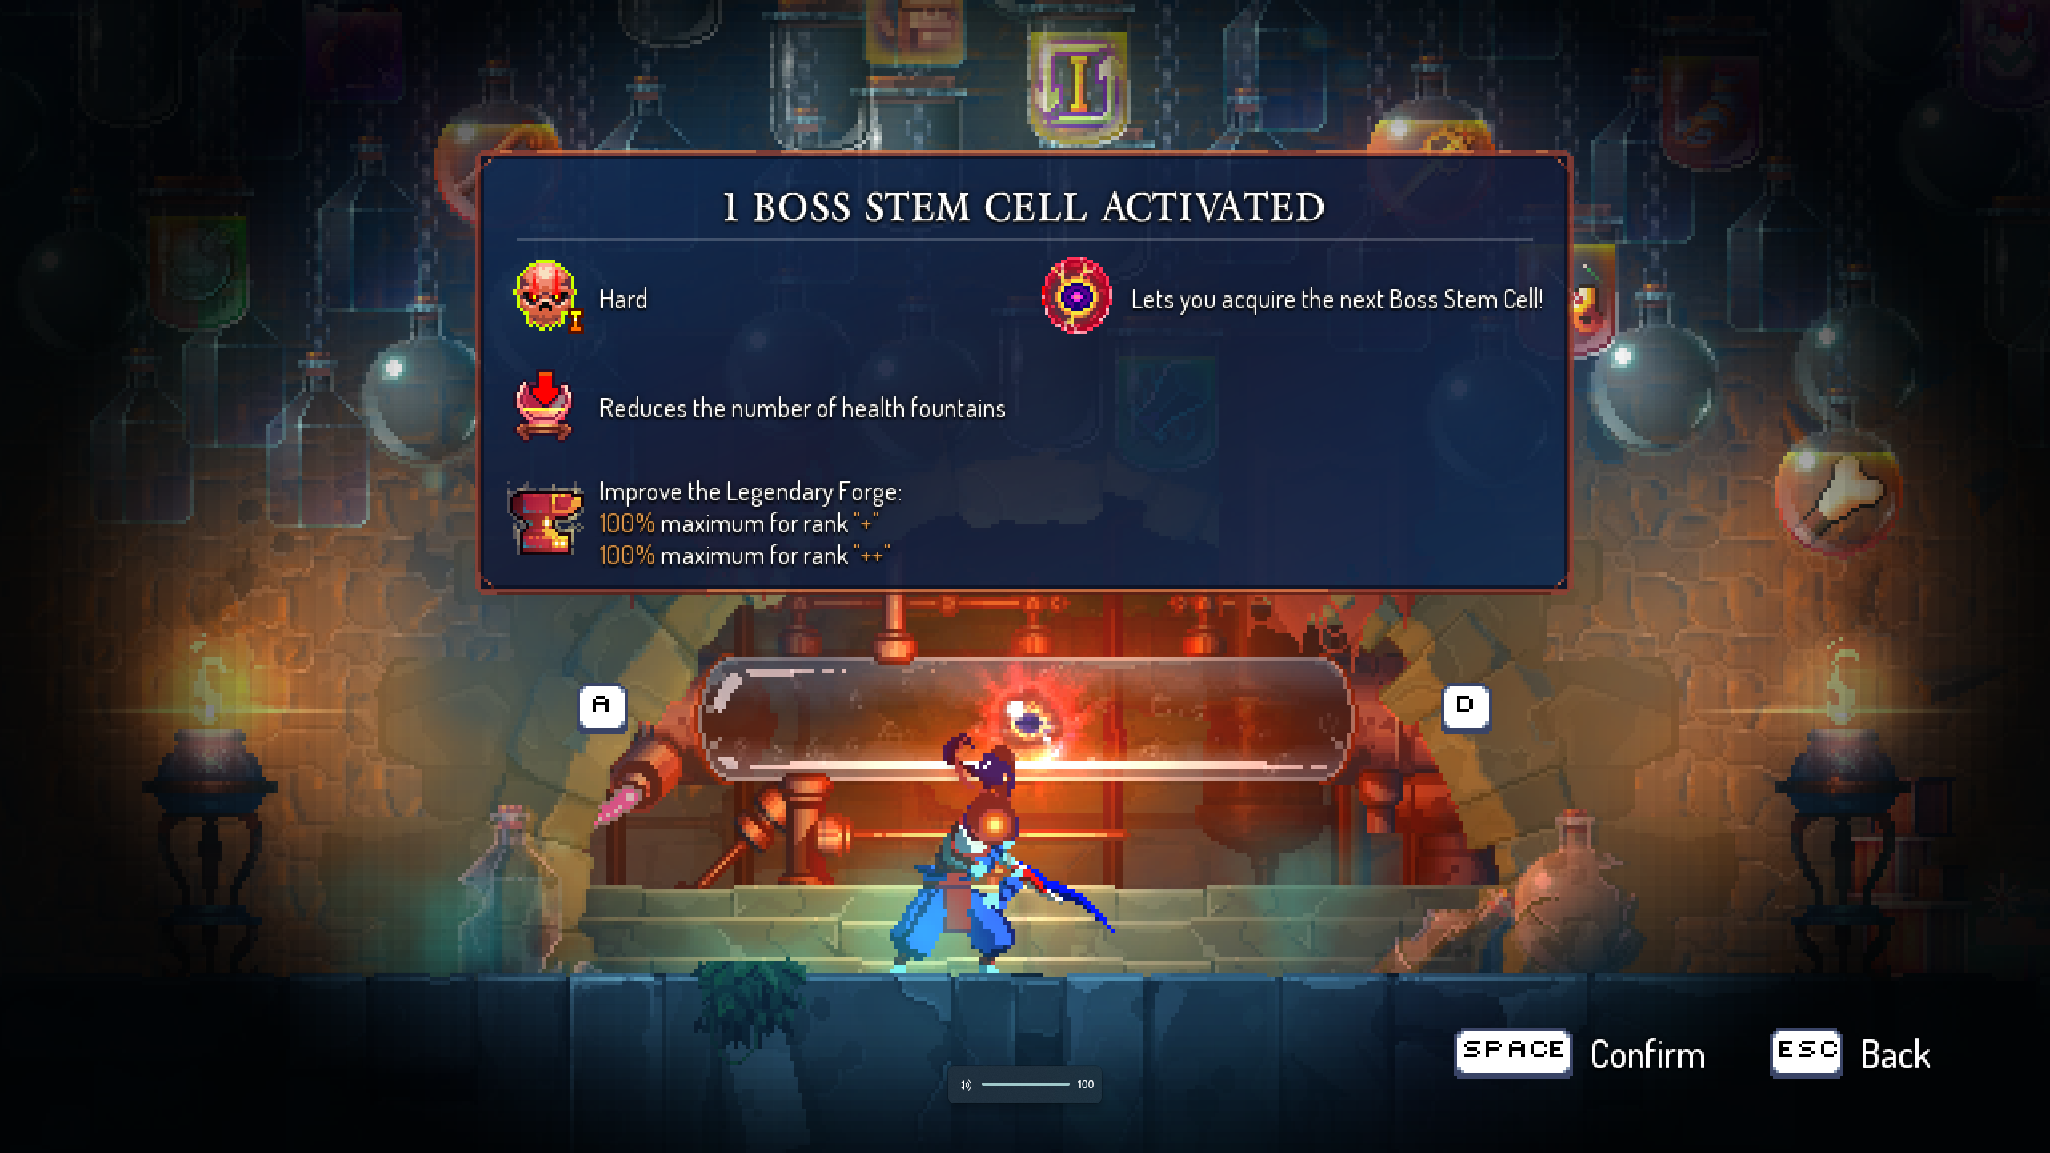^ Boss cells can provide extra difficulty in runs to be able to progress further, forcing the player to get better at the game or try different strategies.
My final highlighted feature about Dead Cells is the vast range of playstyles you can use. I appreciate that this is a common feature in most roguelite games, but I believe that Dead Cells does this especially well, as all weapons, perks and utility items are colour coded into 3 attributes: Brutality, Tactics and Survival, which all offer various perks leaning into different suggested strategies. Moreover, the game offers a custom mode where you can choose which weapons can drop in the standard loot pool, meaning you can specialise in the weapons you choose, or have an easy way to learn new ones. Every weapon comes with unique abilities, which makes combat a lot more complex, yet when mastered it is intensely rewarding.
Dead Cells has relatively cheap minimum requirements:
OS: Windows 7+
Processor: Intel i5+ (or equivalent)
Memory: 2GB RAM
Graphics: Nvidia 450 GTS / Radeon HD 5750
Storage: 500MB
Overall, I would say that Dead Cells is one of my biggest inspirations in terms of my project’s functionality and general gameplay. I like the various combat mechanics, modular upgrades and scaling replayability, along with impressive biome generation.

Objects in the game and their methods
In Dead Cells, there are a plethora of different objects with unique interactions. (reminder to elaborate)

Example 2: Undertale by Toby Fox

General Overview
Undertale was another massive inspiration for where I wanted to go with this project, although more for the story and world-building elements. (Again, conveniently my method of research was through playing it). In Undertale, you play as a child who has fallen down into a world of monsters. You traverse through “The Underground” and meet various other creatures along the way. You can choose to interact with them in various ways, and the story can branch out into 3 core endings, Pacifist, Neutral or Genocide. The game has incredible sound design and despite being a relatively small and linear map, Toby Fox does a very good job of turning it into a functional world, with every NPC having unique and charming dialogue.

If I were to point out some key features in Undertale that I enjoyed, the first would have to be its sound design. The Undertale OST perfectly encapsulates the journey you take through this complex world and leads to some intense moments in the story. Every main encounter has its own motif, and every section of the map has a variety of ambient sounds as well as music that shows the player where they are. In my opinion, the Undertale (and subsequently Deltarune) soundtrack is the best out of any of the games I have played for the emotion it conveys towards the story. In terms of trying to emulate this in my own game, I appreciate Toby Fox’s use of character leitmotifs to connect the world in his game, and I would like to try to add similar features if I choose to do my own soundtrack.

Another aspect I enjoyed was the dialogue with the various NPCs across the world. As Undertale has no voice acting, the voices of the NPC’s are represented by text scrolling across the screen and the sound effects that this makes. However, despite the (somewhat) silent voices, Toby Fox gave every minor character humorous and charming dialogue so every single character in Undertale has a distinct personality.
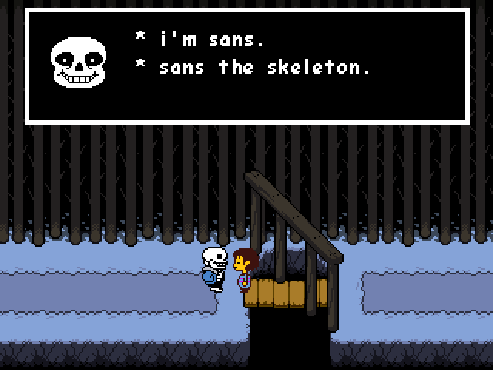
^ Each character has their own unique and in-depth dialogue.

I would also like to briefly touch upon the “combat” in Undertale. Technically, attacking is a very simple mechanic, but I would like to highlight the survival aspect. In these encounters, your soul is trapped inside a box on your screen, and you must dodge enemy attacks using the direction keys. Every character you encounter has a different collection of attacks and the encounters are fun while also being very challenging, with muscle memory being key. I expect I will probably opt for a combat system more like Dead Cells, but I would not be against trying to incorporate one similar to Undertale.
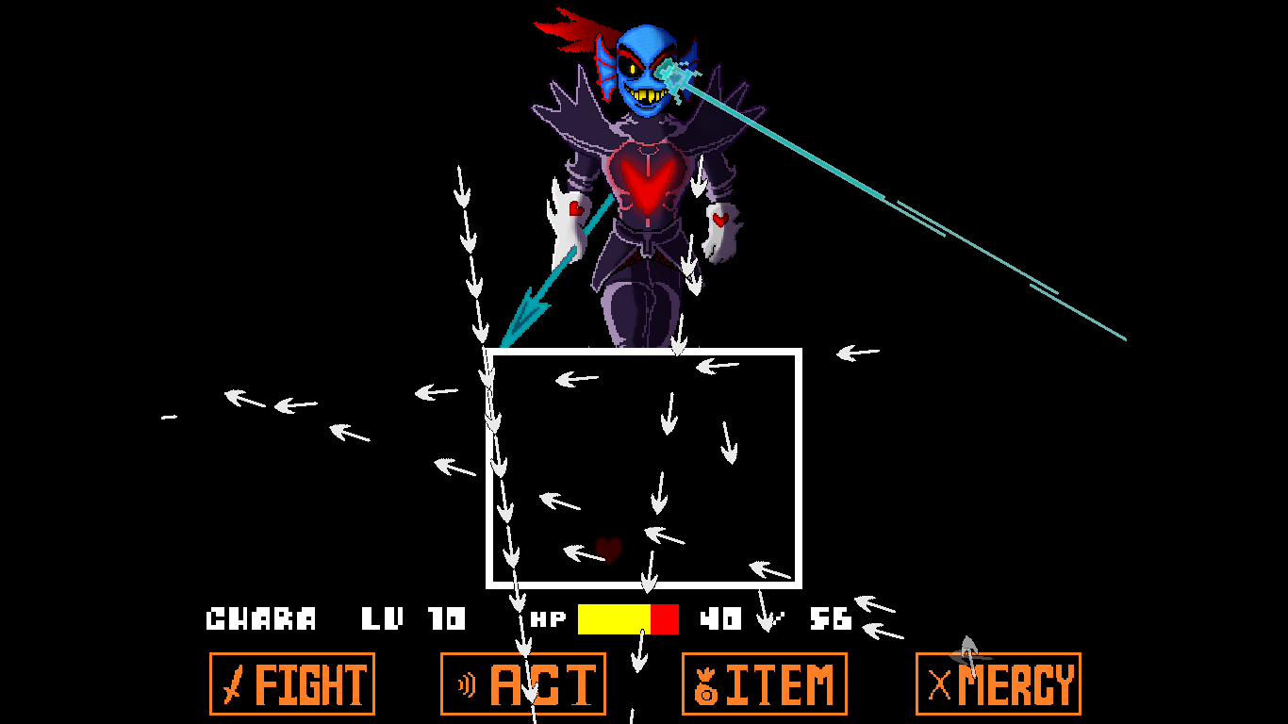
^ The combat in Undertale is unique in that you can choose to be non-violent but still have to survive.

Another good thing about Undertale is that it requires very low-end specs:
OS: Windows XP, Vista, 7
Memory: 2GB RAM
Graphics: 128MB
Storage: 200MB

Overall, I would like to highlight Undertale’s simple but amazingly effective worldbuilding, through its soundtrack, character dialogue and branching story.

Objects in the game and their methods
In Undertale, the objects can be split up into two categories: Combat objects and Out-of-combat objects. It is easier to separate these as they differ in terms of collisions.
In combat, you play as a heart (your soul) with a fixed hitbox, inside a rigid-body box on-screen which prevents you from escaping. Essentially any other object will damage you if you collide with it and reduce your HP. These objects will be the enemies’ attacks and visually they differ wildly but often these are some form of projectile. It is worth noting that there are some exceptions to this that either have a different effect or some additional conditions to cause damage – conveniently they are colour coded so this can be generalised:
- White attacks damage the player on collision, so must be dodged.
- Grey attacks deal no damage and are usually only used for aesthetic purposes.
- Green attacks will heal the player up to a certain number of HP.
- Blue attacks will only damage the player if the player is moving (pressing any arrow key) during the collision.
- Red attacks usually do no damage but warn of upcoming attack
- Orange attacks do not deal damage if the player is moving upon collision
- Yellow attacks show some kind of off/on switch or trigger
Moreover, the player soul character can change colour to give various stage effects:
- When red, the soul is in normal mode. It can move in any direction at a constant speed.
- When blue, the soul is in jump mode and is affected by gravity, much like a platformer perspective. In some cases, the gravity can be forced into all four directions as opposed to straight down.
- When green, the soul is in shield mode and cannot move but wields a shield. Instead of moving, the protagonist must press the arrow keys to protect projectiles coming from one direction.
- When purple, the soul is in trap mode and can only move left and right on a line and switch between lines using up and down.
- When yellow, the soul is in shooter mode and is flipped upside down like a monster’s soul, so its heart’s point is directed towards the enemy. In this mode, you can shoot a projectile that can destroy enemy projectiles or set off bombs, as well as damage the enemy in certain situations.
The player cannot manually switch between these modes- they are usually forced into them by enemies or other NPCs during combat.

Out of combat, there are fewer different examples of collisions, mostly the objects just force the player to stop moving in that direction, to act as rigid bodies that can’t be walked through. In most cases, NPCs can be interacted with to open dialogue with the player. Before the Undyne boss-fight, spear projectiles are thrown onto the map which must be dodged otherwise the player is forced into a combat scenario where they must dodge a flurry of spear attacks and cannot fight back. Other than this, there are various puzzles towards the start of the game that feature buttons, levers, and falling platforms to encourage the player to solve them.

Some more relevant games I researched (and enjoyed enough to mention):
- Celeste: The sound design is incredible, similar to Undertale, and also reflects a similar genre to the game I want to create.
- Hollow Knight: This is another game with a similar genre to the one I want to produce, with an impressive hand-drawn art-style. I appreciated the precision needed to progress in this game, as well as how the story is told so you can piece it together yourself. I like its use of environmental storytelling without directly telling the player and I would like to do something similar in my project.
Detroit: Become Human: This is an example of a game with a widely branching story and incredibly well written, complex characters. I enjoyed the dialogue system and the variable character relations and will hopefully add this to my project.

Initial Feature List

Must have:
Feature | Justification
Basic movement features | This is simply necessary for the user to be able to interact with the game.
Unique level designs | For the game to make sense, it must have multiple levels – I would like these to be unique and visually distinct enough for the player to be able to look at any section of the level and identify which level they are on.
Unique character designs | In order for the player to keep track of what is happening on their screen, all characters must have distinct and different designs to avoid confusion.
Functioning combat system | Initially I would prefer to keep this fairly simple, featuring attacks, getting attacked and recovering health. Implementing a block/parry system is an option I want to consider but I want the basics to be working first.
Basic enemy objects | I want to implement a few different enemy types but do this from an OOP perspective: I will create one base enemy, and any others will inherit characteristics from this if I create more.
Ability upgrades | This is a fairly vague description but initially I want to keep it that way so I can go in a direction I choose; this more refers to additional abilities that the player didn’t have previously as opposed to stat upgrades.

Should have:
Features | Justification
A range of permanent upgrades | I want the game to be roguelite, not roguelike so to avoid the game being overly difficult and punishing I wish to incorporate some upgrades that will be present permanently, as well as some that only exist in specific runs.
Permadeath feature | This may be more appropriately described as a reset of a character’s weapons, stats and most abilities – as stated prior some will be permanent so permadeath may not be strictly accurate.
Mixture of stat upgrades and unique powers | This will include movement abilities to give the game a Metroidvania style, but potentially also could include some form of combat abilities, increased stats, etc.
Dialogue between characters | This most likely will be implemented in the introduction to the game, the “tutorial” will be in the form of a secondary character’s dialogue.
Game saving ability | This is obviously important so the player does not have to complete the game in one sitting – they can come back to it later and start from where they left off.
Solid endgame objective | This should be an easy-to-understand reason for the game to take place, so there is some rationale for the player to be trying to progress.
Variety of unique weapons | This should at least feature 2-3 distinct types of weapons. Due to the scope of my project, I will likely limit the number of different weapons they are but if I have time I would like to add more.
Basic minimap feature | As the levels may vary between runs, I want to include a minimap that shows the players route in the level – areas they have been to will be revealed and areas that are unexplored will be hidden.  I may go in multiple directions for this – I am considering having the minimap reveal be permanent between runs. This will depend on how long each level is and how many variations there are. Alternatively, the minimap will reset between runs, however this may not make sense as it may not necessarily be a level layout that the player hasn’t already beaten.
Basic HUD | I want the player to have a simplified view of their inventory, health and minimap, so they don’t need to access menus to be able to check these things, maximising the time they spend actually playing as opposed to searching for information

Could have:
Features | Justification
Unique currency or currencies for upgrades | Having different currencies for different types of upgrades is a feature I have seen in other games that appeal to me. This would not be strictly necessary to the game but would add a level of detail to the upgrade system, as well as a general challenge to the player as one currency may not apply to an upgrade they want.
Variety to level design so they are unique to different runs | This correlates to my point about making each level’s style be uniquely identifiable. I want to have 3-4 variations of each level so the player isn’t able to always take one route and must explore.
Overall story or lore to the game | I think I would enjoy the worldbuilding aspect to this. Whether or not I implement a more in-depth story behind the gameplay will depend on time. I think having some story will absolutely be helpful, but the depth or quality may vary.
“Prestige” feature | This would reset permanent abilities and progress in exchange for some general stat buffs, or perhaps movement abilities to unlock new map areas. This is not necessary for the game to function but would drastically add replayability to the game.
Synergy between upgrades | This would improve the general gameplay, and would lead to more satisfying movement and combat, letting the player lean into more deliberate playstyles. However, balancing this may be difficult so I am unsure whether to attempt this.
Themed upgrade cards | I am considering using tarot cards to reflect ability upgrades (non-permanent) – this potentially limits the total I can make but artistically appeals to me.
Boss fights | This would make the combat in game more challenging and would require the player to actually fight – due to the nature of the game, it may not be fully required previously.
Branching story and dialogue | This would make the story more engaging as the player’s choices would be able to affect the in-game world.
Controller compatibility | Controller compatibility would increase the population of the target audience: now players who use games consoles would be able to play despite not having a mouse and keyboard.
Control rebind options | I believe that this would be a good quality of life upgrade for players, as if they do not like playing with the default keybind options, they can customise this to something that suits them.

Won’t have:
Features | Justification
Linear Progression | This is purely for design reasons, and also the genre of the game. I want players to have to work for progression – some aspects of this they may find harder than others so by this logic if I wanted a challenging game, progression should not be linear.
Detailed character design | This is an artistic choice and also due to time restraints.
Armour system | Due to time restraints but also necessity I feel that a full armour system would overcomplicate the game.
Huge range of weapons | In theory I would like to have many unique weapons but due to scope it would not be a good idea, as it is not necessary to the functionality of the game.
Procedural level generation | This was a feature in Dead Cells that I especially enjoyed, however it would be too complex to produce and debug within the time constraints I have.
Complex animation | Again, due to time constraints, I think that it would be wiser to focus elsewhere, this would not directly contribute to the functioning of the game so I will omit this.
Overly deep narrative trees | Despite my desire to include branching dialogue, I would like to limit this to 2-3 main options. A deep narrative tree would add to the immersion however the game in itself does not necessarily need this.

In general, I have many ideas for this project, however due to time constraints I must cut some things out so I can keep a reasonably sized scope for the limited time I have to work on this. In the future, I want the option to further develop this game, so I want to lay solid foundations so that I may build upon them if I choose to.

Success Criteria*

Hardware and Software Requirements*
I will be creating my game using Unity, coding in C# with Visual Studio 2022 as my IDE.
The product user will need a computer with around 1GB RAM and 400MB of storage. The game will be optimised for Windows OS, but will be playable on Linux and potentially also macOS.
Operating System | Windows 10+, Linux, macOS 10.14+
Memory | 4GB+ available
Graphics | GTX 1050 Ti + / RX 470 +
Storage | 400-500MB available

Essential Computational Features

Abstraction:
When designing the minimap, I will use less detail than the actual level map so the user can navigate effectively, while removing the need for increased graphics and textures. Moreover, when designing player and enemy sprites, I will be using a simplified geometric hitbox, so it will work as intended without the need for it being precisely mapped to each different object. The upgrades chosen will be shown on screen with a simplified icon (if I go forward with my tarot card idea then these can be the symbols for the cards that already exist), so the player can recognise the upgrades that they have chosen without the need for high detail cards on screen at all times.

Thinking Ahead:
I am planning on creating 3 distinct levels (each with 2-3 variations), and a boss-fight area. Additionally, I will create a menu screen, a settings screen, an inventory screen, an expanded minimap screen, a game over screen and individual upgrade cards that can be displayed on a designated upgrade screen.
My initial movement inputs will be WASD, with the space bar also being an alternative for jumping. Left Shift will be a roll/dodge mechanic, M for the extended minimap, and I want the primary keys for different abilities to be Q, E, R, C. I will also add an option to rebind these keys to the user’s preference. Left and Right Click will be the attack buttons for either of the weapons the player has equipped. This may vary slightly if I add controller compatibility: Using the standard Xbox controller model, the Left Joystick and D-Pad will be movement options, X and Y will be the two weapon buttons, and the bumpers and triggers will be for the different abilities. B will serve as the roll/dodge button and again I will add an option to change these.

Thinking procedurally*:
I will try to break everything down into core subroutines – movement, attacks, collisions

Thinking concurrently*:

Design

Coursework Weapons and Combat
In my project, I want a wide range of weapons in terms of damage, speed, range and AOE, plus additional unique effects applied to all so every weapon feels different to use and can encourage a new playstyle. I also want each weapon to be visually unique so a player can recognise weapons that they like from a distance even when not hovering over with their mouse. I want each weapon to have some basic description, basic stat breakdown and active effects shown on screen when a player hovers over it and is standing near that weapon. I may also potentially add an option to see a detailed statistical breakdown in a side menu. I want the player to be able to wield 1-2 weapons, with standard weapons taking up 1 slot and heavy weapons taking up 2. If the player chooses to wield 2 of the same weapons, I want to implement an akimbo move-set with potentially unique and additional moves. I think that limiting the second weapon slot to the first introductory upgrade will be a good step to encourage the player to push for completion and will be rewarding when unlocked. I think it would be a good idea to feature multiple distinct tiers of weapon, so that scaling can be applied on a wider scale and the player has a general sense of the power of their weapon if they haven't used it before.

Development

Evaluation

References
Celeste. (2018, January 25). Maddy Makes Games.
Dead Cells. (2017, May 10). Motion Twin.
Detroit: Become Human. (2018, May 25). Quantic Dream.
Fox, T. (2015, September 15). Undertale. Toby Fox.
Hollow Knight. (2017, February 24). Team Cherry.
Motion Twin. (2017). Dead Cells. Retrieved from Steam: https://store.steampowered.com/app/588650/Dead_Cells/
Toby Fox. (2015). Undertale store page. Retrieved from Steam: https://store.steampowered.com/app/391540/Undertale/
Undertale Wiki. (2026). Attack Types - Undertale Wiki. Retrieved from Fandom: https://undertale.fandom.com/wiki/Attack_Types#White_Attack
Undertale Wiki. (2026). SOUL Modes - Undertale Wiki. Retrieved from Fandom: https://undertale.fandom.com/wiki/SOUL_Modes#Red

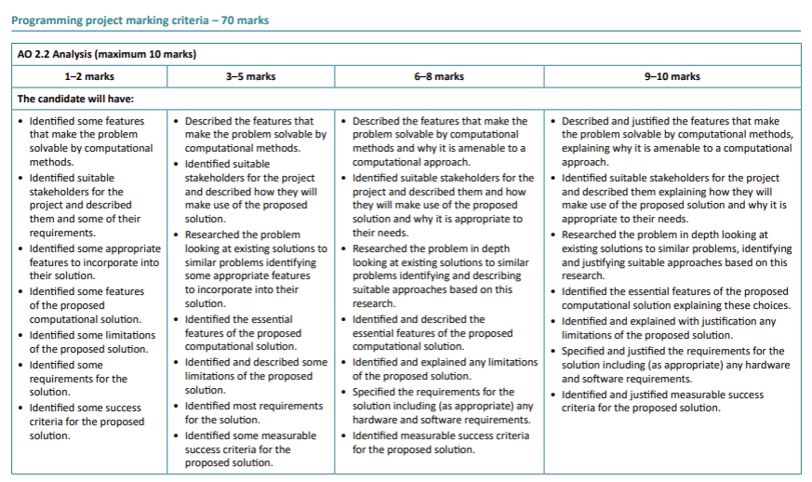
Mark Scheme

(Dead Cells, 2017)
(Motion Twin, 2017)
(Undertale, 2015)
(Toby Fox, 2015)
(Attack Types - Undertale Wiki)
(SOUL Modes - Undertale Wiki)
(Celeste, 2018)
(Hollow Knight, 2017)
(Detroit: Become Human, 2018)
(Dead Cells, 2017)

